"Kyiv Vocational College of Communication"

Cyclic Commission of Computer Engineering

EXECUTION REPORT

**Work - Case #3**

**from the discipline: "Operating systems"**

**Topic:** WORK-CASES IN LINUX

a list of additional practical tasks

from the discipline "Operating Systems"

It was performed by students of the RPZ group - 03B

Team 6: Sichkar Maxim,

Brytyuk Bohdan

Kyiv 2023

**Work-case 3**

● Cloning of your virtual working OS (working example 2). How is this

can it be done? Demonstrate all stages;

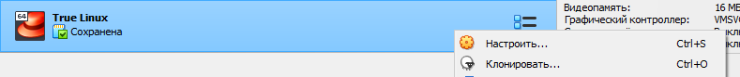

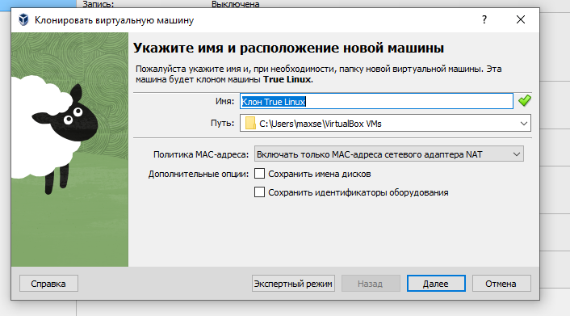

● It is possible to find the need to transfer (clone) the OS to another

virtual environment. What steps should be taken to export to your country

virtual working OS?

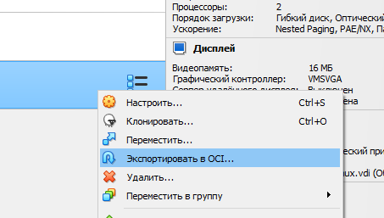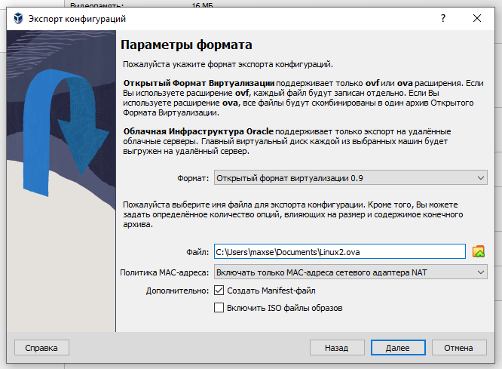

**2. During operation, one working virtual machine can interact with another.**

**For this, it is necessary to deploy a network between them. Describe what types network connection organizations are supported in a virtual environment machines, what is the peculiarity of each of them:**

**Network Address Translation (NAT):** In this type of network connection, the virtual machine is connected to the host machine's network through a virtual NAT device. The virtual NAT device provides a private IP address to the virtual machine, which is translated into the host machine's IP address for communication with the outside world. This type of network connection is useful for scenarios where the virtual machine needs to access the internet, but does not need to be directly accessible from outside the host machine.

**Network Bridge (Bridged):** In a bridged network connection, the virtual machine is connected directly to the host machine's physical network adapter. This allows the virtual machine to have its own unique IP address on the network, just like any other physical machine on the network. This type of network connection is useful for scenarios where the virtual machine needs to be accessible from other machines on the network.

**Virtual Host Adapter (Host-only):** In a host-only network connection, the virtual machine is connected to a virtual network adapter that is only accessible from the host machine. This allows the virtual machines to communicate with each other and with the host machine, but not with any other machines on the physical network. This type of network connection is useful for scenarios where the virtual machines need to communicate with each other, but do not need to access the internet or be accessible from outside the host machine.

**Internal Network:** In an internal network connection, the virtual machines are connected to a virtual network adapter that is only accessible to other virtual machines running on the same host machine. This allows the virtual machines to communicate with each other, but not with any other machines on the physical network or the host machine. This type of network connection is useful for scenarios where multiple virtual machines need to communicate with each other in a secure and isolated environment.

**3. Deploy a network between your production OS and its clone (Task 1):**

**● Demonstrate basic network configuration commands OS options, explain what they do.**

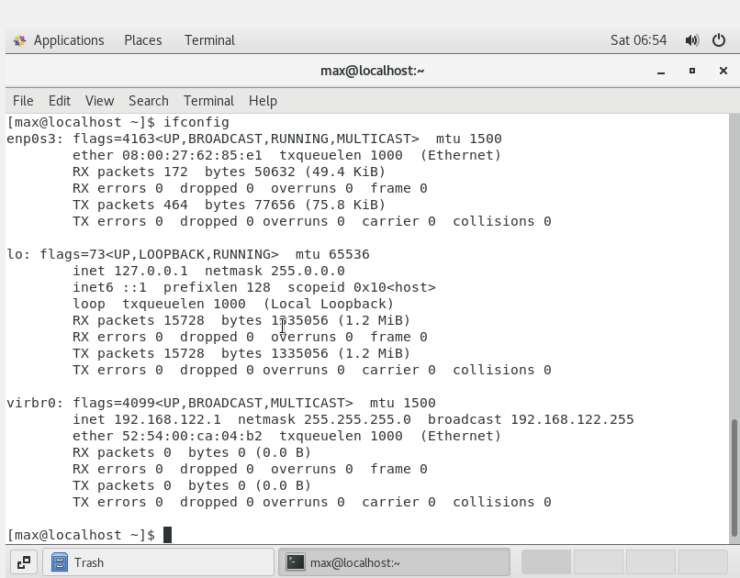

ifconfig - Shows the configuration of network interfaces such as IP address, MAC address, subnet mask, packet counters, etc.

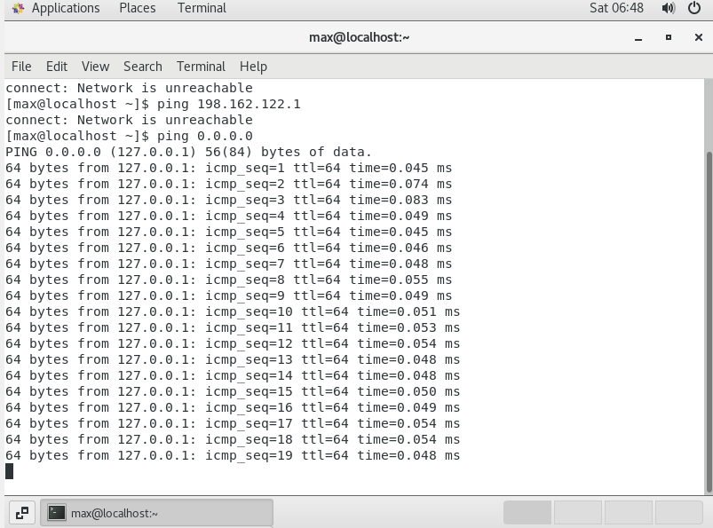

ping <address> - checks the availability of the specified address (for example, ping 8.8.8.8)

**● Both operating systems must have access to the Internet. Open your browser and watch any video on youtube**

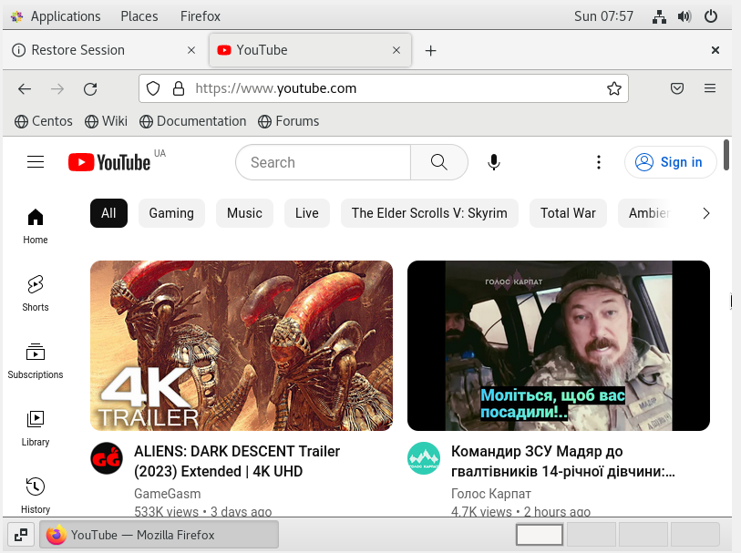

**● Configure and demonstrate messaging between two OSes**

**local network. What commands should be entered in the terminal?**

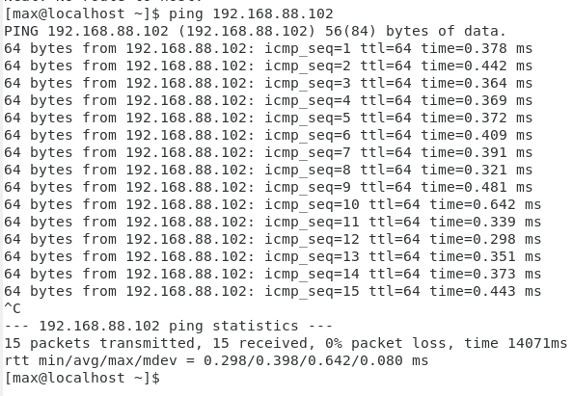

**● Configure a shared network folder for both OSes. Try to copy files from this directory to the user's home directory (virtual**

**working OS) and on the desktop (virtual working OS clone).**

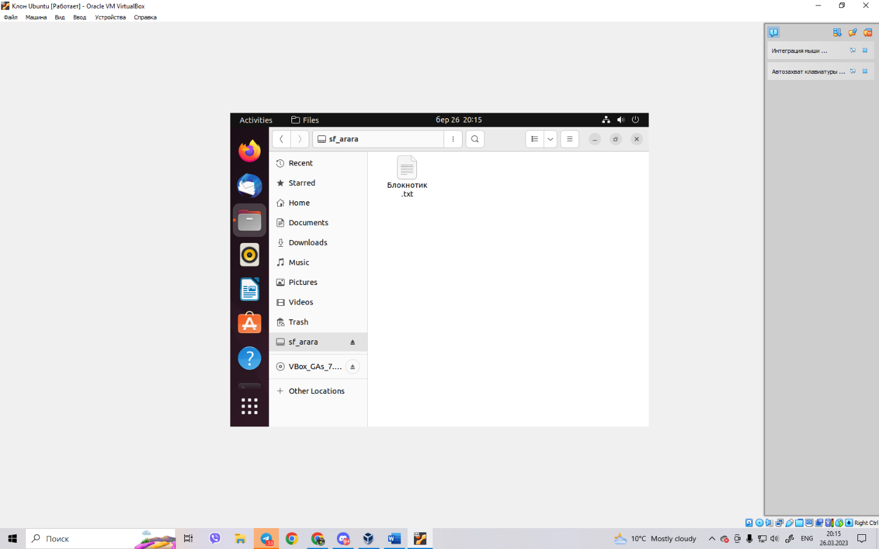

**4. How can you organize the exchange of information between your main**

**OS (eg Windows) and virtual OS? Copy any audio file from your main OS to the desktop of the virtual OS and its clone. As do the reverse action when you need a document from the desktop of the virtual OS copy to your main working OS?**

To organize the exchange of information between the main operating system (like Windows) and virtual OSes, there are several ways to do so:

Shared Folders: Many virtual machine software provide the option to share folders between the host and guest OS. This allows you to easily copy files from your main OS to the virtual OS and vice versa. To share a folder between the host and guest OS, you will need to configure it in the virtual machine settings and install any necessary drivers in the guest OS.

Drag and Drop: Some virtual machine software also support drag and drop functionality between the host and guest OS. This allows you to simply drag a file from your main OS and drop it into the virtual OS, and vice versa. However, this feature may not be available in all virtual machine software.

Clipboard Sharing: Clipboard sharing allows you to copy and paste text and images between the host and guest OS. This can be useful for transferring small amounts of data, but is not ideal for larger files like audio files.

To copy an audio file from the main OS to the virtual OS workspace and its clone using shared folders, follow these steps:

In the virtual machine software, configure a shared folder between the host and guest OS.

In the main OS, navigate to the location of the audio file you wish to copy.

Copy the audio file to the shared folder.

In the virtual OS, navigate to the shared folder location.

Copy the audio file from the shared folder to the desired location in the virtual OS.

If you have cloned the virtual OS, repeat steps 4 and 5 for the cloned virtual OS.

To copy a document from the desktop of the virtual OS to the main working OS using shared folders, follow these steps:

In the virtual machine software, configure a shared folder between the host and guest OS.

In the virtual OS, navigate to the location of the document on the desktop.

Copy the document to the shared folder.

In the main OS, navigate to the shared folder location.

Copy the document from the shared folder to the desired location on the main OS.

**Conclusion:** virtual machines provide a convenient way to run multiple operating systems on a single physical machine. To enable communication and information exchange between the main operating system and virtual machines, various network connection options are available, including NAT, bridged, host-only, and internal network connections. Additionally, shared folders, drag and drop, and clipboard sharing can be used to exchange files and data between the host and guest operating systems. By understanding these options and utilizing the appropriate tools, users can easily share and transfer files and data between their main operating system and virtual machines, making it easier to manage multiple operating systems on a single machine.